Systematic Biology – Supporting Information

From Genomics to Integrative Taxonomy? The Case Study of Pocillopora Corals
Nicolas Oury, Cyril Noël, Stefano Mona, Didier Aurelle, and Hélène Magalon

Correspondence: N. Oury, UMR ENTROPIE, Université de La Réunion, Faculté des Sciences et Technologies, 15 bd René Cassin, CS 92003, 97744 St Denis Cedex 09, La Réunion. E-mail: nicolasoury@hotmail.fr

Appendix 2 Molecular Analyses.

Table of contents
DNA Extraction, Library Preparation, and Sequencing 1
Reference Sequences Construction 2
Reads Mapping, SNP Calling, and Filtering 3
Phylogenomic Analyses 4
Species Delimitation Analyses and Divergence Time Estimation 6
References 7
Tables and Figures
Table S3 Softwares, tools, and parameters 10
Table S4 SNP filtering steps 12
Table S5 Species delimitation models 13
Table S6 Genomic species hypotheses geographical distribution 16
Table S7 F_{ST} between groups 17
Table S8 mtORF haplotype diversity 18
Table S9 PocHistone haplotype diversity 19
Fig. S2 Pocillopora SNP phylogeny with all SNPs 20
Fig. S3 Assignment tests with one SNP per locus 21
Fig. S4 Assignment tests with all SNPs 25
Fig. S5 Networks 28
Fig. S6 F_{ST} heat maps 30
Fig. S7 PocHistone phylogeny 31
Fig. S8 Alternative species tree topologies 32

DNA Extraction, Library Preparation, and Sequencing
Total genomic DNA was extracted using DNeasy® Blood & Tissue kit (QIAGEN GmbH, Hilden, Germany), following the manufacturer protocol. DNA quality was assessed using a NanoDropTM 2000 spectrophotometer (Thermo Fisher Scientific, Wilmington, DE), while initial DNA concentration was measured with a Qubit® 2.0 fluorometer, using the Qubit® dsDNA BR Assay kit (Invitrogen, Carlsbad, CA). Library preparation with NEBNext® Ultra™ II FS DNA Library Prep kit for Illumina (New England Biolabs, Ipswich, MA) and sequencing were then performed at the platform iGenSeq (ICM, Paris, France). Briefly, ca. 100 ng of DNA was enzymatically fragmented to 200-450 bp, followed by end repair, A-tailing, and adaptor ligation according to the manufacturer’s instructions. Then, adaptor-ligated fragments were size-selected (200-350 bp insert sizes), PCR-enriched, and indexed. PCR reactions were cleaned up and library quality was assessed on an Agilent 4200 TapeStation System (Agilent Technologies, Santa Clara, CA). Eight samples were independently prepared twice (sequencing replicates) to estimate the sequencing error rate, and the variant calling and filtering accuracy. Individual libraries were equimollary pooled per 32, and each resulting pool was enriched for a set of 1,248 ultraconserved elements (UCEs) and 1,385 exon loci originally designed from alignments of various anthozoan genomes and transcriptomes (Quattrini et al. 2018), using 17,302 synthetic RNA capture probes (myBaits®, Arbor Bioscences, Ann Arbor, MI). Target-enriched pools were then combined at equimolar ratios prior to PE150 sequencing with an Illumina NovaSeq 6000 (Illumina, San Diego, CA).

Reference Sequences Construction
Following sequencing, the Illumina BaseSpace platform converted BCL data to fastq format and demultiplexed each sample according to individual-specific indexes (no mismatches allowed). All softwares and parameters used hereafter are summarised in Table S3.
Sequence reads from 50 individuals distributed among localities and morphotypes were used to de novo construct reference sequences for the targeted UCEs and exons. Reads were quality checked with FastQC v0.11.7 (http://www.bioinformatics.babraham.ac.uk/projects/fastqc/) and MultiQC v1.7 (Ewels et al. 2016), before and after adapter contamination and low-quality bases removal with cutadapt v2.1 (Martin 2011), available in the wrapper script Trim Galore! v0.6.0 (http://www.bioinformatics.babraham.ac.uk/projects/trim_galore/). Trimmed reads were de novo assembled using SPAdes v3.13.0 (Bankevich et al. 2012), and the resulting scaffolds were matched to the 17,302 RNA capture probes, using the phyluce_assembly_match_contigs_to_probes script from the Phyluce program (Faircloth 2016), to assign each scaffold to one of the 2,633 targeted loci. All scaffolds assigned to the same locus were then aligned using MAFFT v7.713 (Katoh and Standley 2013). A consensus was calculated from each sequence alignment with the cons program from the EMBOSS v6.5.7 suite (Rice et al. 2000) and constituted the reference sequence for the corresponding locus. When sequence alignments grouped highly divergent sequences (indicating potential paralogs or probes targeting several, more or less independent, regions), multiple alignments and consensus were calculated (this was the case for one UCE and 24 exons). This approach allowed to recover a reference sequence for 1,054 of the 1,248 targeted UCEs (84.5%) and 957 of the 1,385 targeted exons (69.1%).
Afterward, to retrieve additional loci, the trimmed reads from the 50 individuals were mapped to the already recovered locus reference sequences using a Burrows-Wheeler aligner (BWA v0.7.17; Li and Durbin 2009). Unmapped reads were filtered using samtools v1.9 (Li et al. 2009; http://www.htslib.org/), then mapped, along with the scaffolds, to the genome of P. acuta (Vidal-Dupiol et al. 2019). Genomic regions with a high read depth (> 30×) over 100 bp for any individual were identified using samtools and custom R v4.0.4 (R Core Team 2021) scripts, and the corresponding scaffolds were aligned as described above to calculate consensus reference sequences. This allows to retrieve 132 additional unidentified loci (named unk-001 to unk-132).
Finally, to identify overlaps or close reference sequences (indicating a physical linkage disequilibrium among loci), the sequences were mapped to the P. acuta genome, as previously for the scaffolds, and merged if necessary (gaps between sequences were filled using the P. acuta genome). Trimmed reads from the 50 individuals were mapped a last time to the reference sequences to perform a final visual check with IGV v2.8.0 (Robinson et al. 2011; Thorvaldsdóttir et al. 2013).
The resulting reference (available at https://XXXXXX) consists of 2,068 sequences with a mean length (± s.e.) of 863.2 ± 7.3 bp.

Reads Mapping, SNP Calling, and Filtering
Sequence reads were quality checked and trimmed as previously, then mapped to the reference sequences using BWA v0.7.17 (Li and Durbin 2009). Reads sorting and duplicates marking were performed with Picard v2.20.7 (https://broadinstitute.github.io/picard/), followed by local realignment with the genome analysis toolkit (GATK) v3.8.1 (McKenna et al. 2010), as in Van der Auwera et al. (2013; Table S3). The reference sequences coverage was estimated for each individual using samtools v1.9 (Li et al. 2009; http://www.htslib.org/), and loci presenting a mean read depth over all individuals < 10× or > 300× (potential paralogs) were discarded. The remaining 1,646 loci were manually investigated and those presenting a pattern compatible with duplicated elements (i.e., paralogs) were also removed to avoid introducing an artificial excess of heterozygous sites generated by the alignment of these divergent regions to the same reference sequence. Finally, 1,620 loci passed these preliminary filtering steps and were retained for subsequent analyses (Table S4).
BCFtools v1.9 (http://samtools.github.io/bcftools/) was used for single-nucleotide polymorphism (SNP) calling, treating all samples simultaneously. A base quality (BQ), a mapping quality (MQ) and a quality score (QUAL) of at least 20, 30 and 20, respectively, were required for calling a variant, while a minimum read depth (DP) of 12× and non-significant strand biases (SP ≤ 13) were required to call a genotype (Tables S3 & S4). From that, a total of 252,043 variants were called out, with a mean divergence (± s.e.) between sequencing replicates of the same individual of 0.16 ± 0.02% (Table S4).
Variants were then filtered using BCFtools and the R library ‘vcfR’ (Knaus and Grünwald 2017; Table S4). Tri- and tetra-allelic sites, as well as sites presenting more than 20% of missing data or a minor allele frequency (MAF) inferior to 0.05 over all individuals were discarded. Three individuals, over the 364 sequenced (outgroups included and sequencing replicates excluded), presenting high proportions of missing data (> 60%) were also discarded at this step, leading to 17,465 SNPs, with a mean divergence (± s.e.) between sequencing replicates of 0.40 ± 0.05% (Table S4). Then, only one representative per replicate was kept (the one with the least missing data), leading to a final dataset of 361 individuals and 17,465 SNPs (Table S4). To reduce the effect of linkage disequilibrium, a second dataset was generated by choosing randomly one SNP per locus (361 individuals × 1,559 SNPs; Table S4).

Phylogenomic Analyses
All following analyses were performed on both datasets (i.e., with one or all SNPs per locus). Available Pocillopora genomes [i.e., P. acuta (Vidal-Dupiol et al. 2019), P. damicornis (Cunning et al. 2018) and P. verrucosa (Buitrago-López et al. 2020)] were also included. For these latter, the SNPs were retrieved by first mapping the reference sequences on each published genome, as previously. Genome regions where the reference sequences were mapped were then extracted using samtools and custom R v4.0.4 (R Core Team 2021) scripts and mapped in return to the reference sequences. SNP genotypes were then called for each genome separately using BCFtools (see Table S3 for the softwares and parameters used).
Filtered SNPs were first converted from VCF to PHYLIP and NEXUS formats using the python script vcf2phylip (https://github.com/edgardomortiz/vcf2phylip). Then, maximum-likelihood (ML) phylogenetic inferences were performed with RAxML-NG v0.9.0 (Kozlov et al. 2019). The phylogeny was constructed using the GTR+G model by searching for the ML tree, with 10 random and 10 parsimony-based starting trees and 10³ bootstrap replicates. Phylogenetic relationships were also investigated by means of Bayesian inference with BEAST v2.6.3 (Bouckaert et al. 2019), using the GTR+G model and an uncorrelated (lognormal) clock model. Chains were run for 5 × 10⁸ iterations, sampling every 5 × 10⁴ iterations, and checked for stationarity and parameter effective sample sizes with Tracer v1.7.1 (Rambaut et al. 2018). Final trees were built using the BEAST module TreeAnnotator v2.6.3 (Bouckaert et al. 2019), discarding the first 20% as burn-in, as indicated by Tracer, and visualised with FigTree v1.4.4 (https://github.com/rambaut/figtree).
To support the phylogenetic analyses and further explore the genetic partitioning of the dataset, several clustering approaches were used. First, assignment tests were performed with Structure v2.3.4 (Pritchard et al. 2000), sNMF (Frichot et al. 2014) and discriminant analyses of principal components (dAPC; Jombart et al. 2010). Structure was run with the admixture model, assuming correlated allele frequencies. Five iterations of 5 × 10⁵ MCMC generations after an initial burn-in of 5 × 10⁴ generations were run for each K, varying from K = 2 to K = 30. sNMF and dAPC were performed with the R libraries ‘LEA’ (Frichot and François 2015) and ‘adegenet’ (Jombart 2008), respectively. Five repetitions per K, with K varying from 2 to 30, were run for sNMF, with a maximum of 500 iterations before reaching stationarity. Results were Structure–like plotted for all three assignment tests (i.e., Structure, sNMF and dAPC) with Clumpak (Kopelman et al. 2015), to allow their comparison. Signals of admixture between two clusters were further investigated with NewHybrids v1.1 (Anderson and Thompson 2002), parallelised with the R library ‘parallelnewhybrid’ (Wringe et al. 2017). For each pair of clusters found admixed, NewHybrids was first run only with pure lineage individuals (i.e., assigned to one cluster or the other with a probability ≥ 0.9) to verify that the clusters were retrieved. Then, admixed individuals were included. One hundred runs, each with 100 randomly chosen SNPs, were performed with 10⁶ iterations after a burn-in period of 10⁵, and resulting assignment probabilities were averaged. Second, Nei (1972) individual genetic distances were computed with the R library ‘StAMPP’ (Pembleton et al. 2013), and then used to build a minimum spanning tree (MST) and an unrooted equal-angle split network using EDENetworks v2.18 (Kivelä et al. 2015) and SplitsTree v4.15.1 (Huson and Bryant 2006), respectively.
Finally, SSH and cluster assignments issued from microsatellite data (Gélin et al. 2017a, 2017b, 2018a, 2018b; Oury et al. 2020, 2021, 2022) were compared to the groups identified with all above analyses, named hereafter genomic species hypotheses (GSHs). F_{ST} (Weir and Cockerham 1984) were computed with ‘StAMPP’ (Pembleton et al. 2013), for each pair of GSHs, and the resulting matrix was clustered using the heatmap.2 function from the R library ‘gplots’ (Warnes et al. 2020).
Besides, as some GSHs did not include any individual whose mtORF had previously been sequenced, and in order to retrieve the correspondence with previous studies, we completed the set of mtORF-sequenced colonies, following Gélin et al. (2017b), and further sequenced a subset of colonies for the PocHistone, a recently discovered marker partly mapped to partial histone 3 genes from other cnidarians, and allowing to identify P. grandis (the senior synonym of P. eydouxi) colonies (Johnston et al. 2018). The same laboratory protocol as for the mtORF was used, and sequencing in both directions was performed on an ABI 3730XL DNA Analyzer at GenoScreen (Lille, France). Sequences were checked and edited using Geneious v8.1.9 (Kearse et al. 2012). mtORF and PocHistone haplotypes were identified by aligning them with those from Gélin et al. (2017b), and from Johnston et al. (2018), respectively (all sequences are available in GenBank). Alignments were performed with MAFFT v7.713 (Katoh and Standley 2013), and sequences were trimmed to the appropriate lengths. Phylogenetic relationships among PocHistone haplotypes were reconstructed in MEGA v7.0.26 (Kumar et al. 2016), with the most appropriate substitution model according to jModelTest v2.1.10 (i.e., the JC+I model; Darriba et al. 2012).

Species Delimitation Analyses and Divergence Time Estimation
To confirm GSHs, Bayes factor delimitation with genomic data (BFD*; Leaché et al. 2014) was used to test several possible species delimitation models, using the SNAPP package (Bryant et al. 2012) implemented in BEAST v2.6.3 (Bouckaert et al. 2019). To deal with computationally intensive demands from SNAPP, we first tested a batch of species delimitation scenarios to confirm the four main clades from the phylogeny (arbitrarily defined as monophyletic groups of individuals separated by nucleotide substitution per site distances of at least 0.4 on the ML tree). Four scenarios were distinguished: (1) one single clade (Clades 1 + 2 + 3 + 4); (2) two clades (Clade 1 | Clades 2 + 3 + 4); (3) three clades (Clade 1 | Clades 2 + 3 | Clade 4) and (4) four clades (Clade 1 | Clade 2 | Clade 3 | Clade 4). Three individuals per clade were sampled, and BCFtools was used to generate the corresponding VCF file, including only unlinked biallelic SNPs from the dataset with one SNP per locus, which was then converted into binary NEXUS format using vcf2phylip. A path sampling method with 48 steps, each one consisting of 10⁵ MCMC generations, storing every 10³ generations with a pre-burn-in of 10³ steps, was run for each scenario, and the first 80% stored data was discarded. Model convergence was assessed with Tracer v1.7.1 (Rambaut et al. 2018) and models were compared and ranked using their marginal likelihood estimation (MLE) and by calculating the Bayes factor (BF; Kass and Raftery 1995). Once this first batch of scenarios tested, we retained the best-supported model, i.e. four clades (see Results). Then, several possible species delimitation models were tested within each clade separately, from one single species to the number of GSHs found for each clade (Table S5). SNAPP was run as above, and the best-supported model was retained for each clade.
For each of the best-supported model (except for Clade 1, constituted of a single GSH), a coalescent-based tree was calculated with SNAPP, keeping only two individuals per GSH to reduce the complexity in species tree estimation and increase the parameter convergence probability. Chains were run for 10⁷ iterations, sampling every 10³ iterations, and checked for convergence with Tracer v1.7.1 (Rambaut et al. 2018). Species trees that were contained in the 95% highest posterior density (HPD) set were then identified with SNAPP-TreeSetAnalyser v2.6.3 (Bryant et al. 2012), discarding the first 10% as burn-in, as suggested by Tracer. DensiTree v2.2.7 (Bouckaert 2010) was used to visualise the posterior distributions of topologies as cladograms, hence allowing for a clear depiction of uncertainty in the topology.
Finally, GSH divergence times were estimated with the BEAST package SNAPPER v1.0.1 (Stoltz et al. 2021). The latter is similar to SNAPP, except that it uses a diffusion model to calculate the likelihood of the species tree instead of mathematically integrating over all possible gene trees. Therefore, SNAPPER is far less computationally demanding than SNAPP and allowed us to include all delimited Pocillopora GSHs (each represented by three individuals) and outgroups (i.e., S. hystrix and S. pistillata; merged into one group) in a single analysis. The divergence between Pocillopora and outgroups was constrained to the middle-end Paleogene (42.7-28.4 Ma; Simpson et al. 2011) with a lognormal distribution (offset = 0, μ = 36, σ = 0.1), and the most probable species tree identified with TreeSetAnalyser was used as starting tree. We used the ruby script snapp_prep (https://github.com/mmatschiner/snapp_prep) to prepare the xml input file, setting a chain of 10⁷ iterations with a sampling every 10³ iterations. Convergence and mixing were checked using Tracer v1.7.1 (Rambaut et al. 2018), and the maximum clade credibility tree with median node heights was generated with TreeAnnotator v2.6.3 (Bouckaert et al. 2019), discarding the first 10% as burn-in.

References
Anderson E.C., Thompson E.A. 2002. A model-based method for identifying species hybrids using multilocus genetic data. Genetics. 160:1217–1229.
Bankevich A., Nurk S., Antipov D., Gurevich A.A., Dvorkin M., Kulikov A.S., Lesin V.M., Nikolenko S.I., Pham S., Prjibelski A.D., Pyshkin A.V., Sirotkin A.V., Vyahhi N., Tesler G., Alekseyev M.A., Pevzner P.A. 2012. SPAdes: a new genome assembly algorithm and its applications to single-cell sequencing. J. Comput. Biol. 19:455–477.
Bouckaert R., Vaughan T.G., Barido-Sottani J., Duchêne S., Fourment M., Gavryushkina A., Heled J., Jones G., Kühnert D., Maio N.D., Matschiner M., Mendes F.K., Müller N.F., Ogilvie H.A., Plessis L. du, Popinga A., Rambaut A., Rasmussen D., Siveroni I., Suchard M.A., Wu C.-H., Xie D., Zhang C., Stadler T., Drummond A.J. 2019. BEAST 2.5: an advanced software platform for Bayesian evolutionary analysis. PLoS Comput. Biol. 15:1006650.
Bouckaert R.R. 2010. DensiTree: making sense of sets of phylogenetic trees. Bioinformatics. 26:1372–1373.
Bryant D., Bouckaert R., Felsenstein J., Rosenberg N.A., RoyChoudhury A. 2012. Inferring species trees directly from biallelic genetic markers: bypassing gene trees in a full coalescent analysis. Mol. Biol. Evol. 29:1917–1932.
Buitrago-López C., Mariappan K.G., Cardenas A., Gegner H.M., Voolstra C.R. 2020. The genome of the cauliflower coral Pocillopora verrucosa. Genome Biol. Evol. 12:1911–1917.
Cunning R., Bay R.A., Gillette P., Baker A.C., Traylor-Knowles N. 2018. Comparative analysis of the Pocillopora damicornis genome highlights role of immune system in coral evolution. Sci. Rep. 8:16134.
Darriba D., Taboada G.L., Doallo R., Posada D. 2012. jModelTest 2: more models, new heuristics and parallel computing. Nat. Methods. 9:772–772.
Ewels P., Magnusson M., Lundin S., Käller M. 2016. MultiQC: summarize analysis results for multiple tools and samples in a single report. Bioinformatics. 32:3047–3048.
Faircloth B.C. 2016. PHYLUCE is a software package for the analysis of conserved genomic loci. Bioinformatics. 32:786–788.
Frichot E., François O. 2015. LEA: an R package for landscape and ecological association studies. Methods Ecol. Evol. 6:925–929.
Frichot E., Mathieu F., Trouillon T., Bouchard G., François O. 2014. Fast and efficient estimation of individual ancestry coefficients. Genetics. 196:973–983.
Gélin P., Fauvelot C., Bigot L., Baly J., Magalon H. 2018a. From population connectivity to the art of striping Russian dolls: the lessons from Pocillopora corals. Ecol. Evol. 8:1411–1426.
Gélin P., Fauvelot C., Mehn V., Bureau S., Rouzé H., Magalon H. 2017a. Superclone expansion, long-distance clonal dispersal and local genetic structuring in the coral Pocillopora damicornis type β in Reunion Island, South Western Indian Ocean. PLoS ONE. 12:0169692.
Gélin P., Pirog A., Fauvelot C., Magalon H. 2018b. High genetic differentiation and low connectivity in the coral Pocillopora damicornis type β at different spatial scales in the Southwestern Indian Ocean and the Tropical Southwestern Pacific. Mar. Biol.:165–167.
Gélin P., Postaire B., Fauvelot C., Magalon H. 2017b. Reevaluating species number, distribution and endemism of the coral genus Pocillopora Lamarck, 1816 using species delimitation methods and microsatellites. Mol. Phylogenet. Evol. 109:430–446.
Huson D.H., Bryant D. 2006. Application of phylogenetic networks in evolutionary studies. Mol. Biol. Evol. 23:254–267.
Johnston E.C., Forsman Z.H., Toonen R.J. 2018. A simple molecular technique for distinguishing species reveals frequent misidentification of Hawaiian corals in the genus Pocillopora. PeerJ. 6:4355.
Jombart T. 2008. adegenet: a R package for the multivariate analysis of genetic markers. Bioinformatics. 24:1403–1405.
Jombart T., Devillard S., Balloux F. 2010. Discriminant analysis of principal components: a new method for the analysis of genetically structured populations. BMC Genet. 11:94.
Kass R.E., Raftery A.E. 1995. Bayes factors. J. Am. Stat. Assoc. 90:773–795.
Katoh K., Standley D.M. 2013. MAFFT multiple sequence alignment software version 7: improvements in performance and usability. Mol. Biol. Evol. 30:772–780.
Kearse M., Moir R., Wilson A., Stones-Havas S., Cheung M., Sturrock S., Buxton S., Cooper A., Markowitz S., Duran C., Thierer T., Ashton B., Meintjes P., Drummond A. 2012. Geneious Basic: an integrated and extendable desktop software platform for the organization and analysis of sequence data. Bioinformatics. 28:1647–1649.
Kivelä M., Arnaud-Haond S., Saramäki J. 2015. EDENetworks: a user-friendly software to build and analyse networks in biogeography, ecology and population genetics. Mol. Ecol. Resour. 15:117–122.
Knaus B.J., Grünwald N.J. 2017. VCFR: a package to manipulate and visualize variant call format data in R. Mol. Ecol. Resour. 17:44–53.
Kopelman N.M., Mayzel J., Jakobsson M., Rosenberg N.A., Mayrose I. 2015. Clumpak: a program for identifying clustering modes and packaging population structure inferences across K. Mol. Ecol. Resour. 15:1179–1191.
Kozlov A.M., Darriba D., Flouri T., Morel B., Stamatakis A. 2019. RAxML-NG: a fast, scalable and user-friendly tool for maximum likelihood phylogenetic inference. Bioinformatics. 35:4453–4455.
Kumar S., Stecher G., Tamura K. 2016. MEGA7: molecular evolutionary genetics analysis version 7.0 for bigger datasets. Mol. Biol. Evol. 33:1870–1874.
Leaché A.D., Fujita M.K., Minin V.N., Bouckaert R.R. 2014. Species delimitation using genome-wide SNP data. Syst. Biol. 63:534–542.
Li H., Durbin R. 2009. Fast and accurate short read alignment with Burrows-Wheeler transform. Bioinformatics. 25:1754–1760.
Li H., Handsaker B., Wysoker A., Fennell T., Ruan J., Homer N., Marth G., Abecasis G., Durbin R., 1000 Genome Project Data Processing Subgroup. 2009. The Sequence Alignment/Map format and SAMtools. Bioinformatics. 25:2078–2079.
Martin M. 2011. Cutadapt removes adapter sequences from high-throughput sequencing reads. EMBnet J. 17:10–12.
McKenna A., Hanna M., Banks E., Sivachenko A., Cibulskis K., Kernytsky A., Garimella K., Altshuler D., Gabriel S., Daly M. 2010. The Genome Analysis Toolkit: a MapReduce framework for analyzing next-generation DNA sequencing data. Genome Res. 20:1297–1303.
Nei M. 1972. Genetic distance between populations. Am. Nat. 106:283–292.
Oury N., Gélin P., Magalon H. 2020. Cryptic species and genetic connectivity among populations of the coral Pocillopora damicornis (Scleractinia) in the tropical southwestern Pacific. Mar. Biol. 167:142.
Oury N., Gélin P., Magalon H. 2021. High connectivity within restricted distribution range in Pocillopora corals. J. Biogeogr. 48:1679–1692.
Oury N., Gélin P., Rajaonarivelo M., Magalon H. 2022. Exploring the Pocillopora cryptic diversity: a new genetic lineage in the Western Indian Ocean or remnants from an ancient one? Mar. Biodivers. 52:5.
Pembleton L.W., Cogan N.O.I., Forster J.W. 2013. StAMPP: an R package for calculation of genetic differentiation and structure of mixed-ploidy level populations. Mol. Ecol. Resour. 13:946–952.
Pritchard J.K., Stephens M., Donnelly P. 2000. Inference of population structure using multilocus genotype data. Genetics. 155:945–959.
Quattrini A.M., Faircloth B.C., Dueñas L.F., Bridge T.C.L., Brugler M.R., Calixto-Botía I.F., DeLeo D.M., Forêt S., Herrera S., Lee S.M.Y., Miller D.J., Prada C., Rádis-Baptista G., Ramírez-Portilla C., Sánchez J.A., Rodríguez E., McFadden C.S. 2018. Universal target-enrichment baits for anthozoan (Cnidaria) phylogenomics: new approaches to long-standing problems. Mol. Ecol. Resour. 18:281–295.
R Core Team. 2021. R: a language and environment for statistical computing. R Foundation for Statistical Computing, Vienna, Austria. URL: https://www.R-project.org/​: .
Rambaut A., Drummond A.J., Xie D., Baele G., Suchard M.A. 2018. Posterior summarization in Bayesian phylogenetics using Tracer 1.7. Syst. Biol. 67:901–904.
Rice P., Longden I., Bleasby A. 2000. EMBOSS: the European molecular biology open software suite. Trends Genet. 16:276–277.
Robinson J.T., Thorvaldsdóttir H., Winckler W., Guttman M., Lander E.S., Getz G., Mesirov J.P. 2011. Integrative genomics viewer. Nat. Biotechnol. 29:24–26.
Simpson C., Kiessling W., Mewis H., Baron‐Szabo R.C., Müller J. 2011. Evolutionary diversification of reef corals: a comparison of the molecular and fossil records. Evolution. 65:3274–3284.
Stoltz M., Baeumer B., Bouckaert R., Fox C., Hiscott G., Bryant D. 2021. Bayesian inference of species trees using diffusion models. Syst. Biol. 70:145–161.
Thorvaldsdóttir H., Robinson J.T., Mesirov J.P. 2013. Integrative Genomics Viewer (IGV): high-performance genomics data visualization and exploration. Brief. Bioinform. 14:178–192.
Van der Auwera G.A., Carneiro M.O., Hartl C., Poplin R., del Angel G., Levy‐Moonshine A., Jordan T., Shakir K., Roazen D., Thibault J., Banks E., Garimella K.V., Altshuler D., Gabriel S., DePristo M.A. 2013. From FastQ data to high‐confidence variant calls: the Genome Analysis Toolkit best practices pipeline. Curr. Protoc. Bioinforma. 43.
Vidal-Dupiol J., Chaparro C., Pratlong M., Pontaroti P., Grunau C., Mitta G. 2019. Sequencing, de novo assembly and annotation of the genome of the scleractinian coral, Pocillopora acuta. BioRxiv.
Warnes G.R., Bolker B., Bonebakker L., Gentleman R., Huber W., Liaw A., Lumley T., Maechler M., Magnusson A., Moeller S., Schwartz M., Venables B. 2020. gplots: various R programming tools for plotting data. R package version 3.1.1.
Weir B.S., Cockerham C.C. 1984. Estimating F-statistics for the analysis of population structure. Evolution. 38:1358–1370.
Wringe B.F., Stanley R.R.E., Jeffery N.W., Anderson E.C., Bradbury I.R. 2017. parallelnewhybrid: an R package for the parallelization of hybrid detection using newhybrids. Mol. Ecol. Resour. 17:91–95.

Table S3 Softwares, tools, and parameters used for processing reads.

Function |  | Tool | Software/package | Parameters | Reference
Reference sequences construction
 | Quality control | FastQC v0.11.7 |  | N/A | [1]
 |  | MultiQC v1.7 |  | N/A | [2]
 | Adapter trimming and low-quality bases removal | Trim Galore! v0.6.0 |  | --paired R1.fq R2.fq | [3]
 |  |  |  | --trim-n
 |  |  |  | --illumina
 |  |  |  | --nextseq 20
 | De novo reads assembly | SPAdes v3.13.0 |  | -1 R1.fq -2 R2.fq | [4]
 |  |  |  | --careful
 |  |  |  | --cov-cutoff 10
 |  |  |  | -k 21,33,55,77
 | Match scaffolds to probes | phyluce_assembly_match_contigs_to_probes | Phyluce | --contigs /path/to/scaffolds.fa | [5]
 |  |  |  | --probes hexa-v2-sclerac-subset-final-probes.fa
 |  |  |  | --regex='^((uce|trans)-\d+)(?:_p\d+.*)'
 | Scaffolds alignment | MAFFT v7.713 |  | --adjustdirection | [6]
 | Calculate consensus | cons | EMBOSS v6.5.7 | -sequence scaffolds_alignment.msa | [7]
 | Reads, scaffolds and sequences mapping | BWA v0.7.17 |  | mem reference.fa R1.fq R2.fq | [8]
 |  |  |  | mem reference.fa scaffolds/sequences.fa
 | Unmapped reads filtering | view | samtools v1.9 | -f 4 | [9,10]
 | Calculate read depth | depth | samtools v1.9 | -m 50 | [9,10]
Reads mapping, SNP calling, and filtering
 | Quality control | FastQC v0.11.7 |  | N/A | [1]
 |  | MultiQC v1.7 |  | N/A | [2]
 | Adapter trimming and low-quality bases removal | Trim Galore! v0.6.0 |  | --paired R1.fq R2.fq | [3]
 |  |  |  | --trim-n
 |  |  |  | --illumina
 |  |  |  | --nextseq 20
 | Reads mapping | BWA v0.7.17 |  | mem reference.fa R1.fq R2.fq | [8]
 | Reads sorting | SortSam | Picard v2.20.7 | SORT_ORDER=coordinate | [11]
 | Duplicates marking | MarkDuplicates | Picard v2.20.7 | ASO=coordinate | [11]
 | Local realignment | RealignerTargetCreator | GATK v3.8.1 | -R reference.fa | [12]
 |  | IndelRealigner |  | -R reference.fa
 | Calculate read depth | depth | samtools v1.9 | N/A | [9,10]

Function |  | Tool | Software/package | Parameters | Reference
Reads mapping, SNP calling, and filtering (continued)
 | SNP calling and filtering | mpileup | BCFtools v1.9 | -A -I -Q 20 -q 30 -a AD,DP,SP,INFO/AD  -f reference.fa | [13]
 |  | call |  | -mv
 |  | filter |  | -i ‘QUAL>=20’
 |  |  |  | -S ‘.’ -e ‘FORMAT/DP<12’
 |  |  |  | -S ‘.’ -e ‘FORMAT/SP>13’
 |  |  |  | -m2 -M2
Published genomes SNP genotyping
 | References mapping | BWA v0.7.17 |  | mem genome.fa reference.fa | [8]
 | Mapped regions extraction | view | samtools v1.9 | N/A | [9,10]
 | Genome mapping | BWA v0.7.17 |  | mem reference.fa genome.fa | [8]
 | SNP genotyping | mpileup | BCFtools v1.9 | -A -B -I -a AD,DP,SP,INFO/AD -R SNP_positions.txt | [13]
 |  |  |  | -f reference.fa
 |  | call |  | -m

References
[1] http://www.bioinformatics.babraham.ac.uk/projects/fastqc/
[2] Ewels P, Magnusson M, Lundin S, Käller M (2016) MultiQC: summarize analysis results for multiple tools and samples in a single report. Bioinformatics 32:3047–3048. doi: 10.1093/bioinformatics/btw354
[3] http://www.bioinformatics.babraham.ac.uk/projects/trim_galore/
[4] Bankevich A, Nurk S, Antipov D, Gurevich AA, Dvorkin M, Kulikov AS, Lesin VM, Nikolenko SI, Pham S, Prjibelski AD, Pyshkin AV, Sirotkin AV, Vyahhi N, Tesler G, Alekseyev MA, Pevzner PA (2012) SPAdes: A new genome assembly algorithm and its applications to single-cell sequencing. Journal of Computational Biology 19:455–477. doi: 10.1089/cmb.2012.0021
[5] Faircloth BC (2016) PHYLUCE is a software package for the analysis of conserved genomic loci. Bioinformatics 32:786–788. doi: 10.1093/bioinformatics/btv646
[6] Katoh K, Standley DM (2013) MAFFT multiple sequence alignment software version 7: Improvements in performance and usability. Molecular Biology and Evolution 30:772–780. doi: 10.1093/molbev/mst010
[7] Rice P, Longden I, Bleasby A (2000) EMBOSS: the European molecular biology open software suite. Trends in Genetics 16:276–277.
[8] Li H, Durbin R (2009) Fast and accurate short read alignment with Burrows-Wheeler transform. Bioinformatics 25:1754–1760. doi: 10.1093/bioinformatics/btp324
[9] Li H, Handsaker B, Wysoker A, Fennell T, Ruan J, Homer N, Marth G, Abecasis G, Durbin R, 1000 Genome Project Data Processing Subgroup (2009) The Sequence Alignment/Map format and SAMtools. Bioinformatics 25:2078–2079. doi: 10.1093/bioinformatics/btp352
[10] http://www.htslib.org/
[11] https://broadinstitute.github.io/picard/
[12] McKenna A, Hanna M, Banks E, Sivachenko A, Cibulskis K, Kernytsky A, Garimella K, Altshuler D, Gabriel S, Daly M (2010) The Genome Analysis Toolkit: a MapReduce framework for analyzing next-generation DNA sequencing data. Genome Res 20:1297–1303. doi: 10.1101/gr.107524.110
[13] http://samtools.github.io/bcftools/
Table S4 Single-nucleotide polymorphism (SNP) filtering steps. N_{ind}, N_{loci}, N_{SNP} and N_{GT}: numbers of individuals, loci, SNPs and genotypes, respectively, %NA, %NA_{ind} and %NA_{SNP}: percentages of missing data for the overall dataset, per individual and per SNP, respectively, Δrep: mean (± s.e.) divergence between sequencing replicates of the same individual (N = 8), MQ: mapping quality, BQ: base quality, DP_{locus}: mean locus depth of coverage overall individuals, QUAL: quality score, DP: genotype depth of coverage, SP: strand bias and MAF: minor allele frequency.

Filters | N_{ind} | N_{loci} | N_{SNP} | N_{GT} | %NA |  | Δrep
MQ ≥ 30 & BQ ≥ 20 | 372 | 2 068 | 430 120 | 138 641 244 | 13.4% |  | 1.14 ± 0.07%
& 10 ≤ DP_{locus} ≤ 300  & no paralogs | 372 | 1 620 | 370 498 | 122 436 721 | 11.2% |  | 0.94 ± 0.07%
& QUAL ≥ 20 | 372 | 1 620 | 347 685 | 116 530 354 | 9.9% |  | 0.97 ± 0.07%
& DP ≥ 12 | 372 | 1 620 | 254 575 | 74 756 826 | 21.1% |  | 0.19 ± 0.02%
& SP < 13 | 372 | 1 620 | 252 043 | 73 941 075 | 21.1% |  | 0.16 ± 0.02%
& no tri/tetra-allelic sites | 372 | 1 620 | 209 658 | 62 249 416 | 20.2% |  | 0.12 ± 0.01%
& %NA_{SNP} ≤ 20  & MAF ≥ 0.05 | 372 | 1 559 | 17 465 | 6 079 709 | 6.4% |  | 0.40 ± 0.05%
& %NA_{ind} ≤ 60 | 369 | 1 559 | 17 465 | 6 074 034 | 5.7% |  | 0.40 ± 0.05%
& no replicate | 361 | 1 559 | 17 465 | 5 939 477 | 5.8% |  | -
& 1 SNP/locus | 361 | 1 559 | 1 559 | 528 855 | 6.0% |  | -

Table S5 Bayes factor delimitation with genomic data (BFD*) results for each model for the first batch of scenarios, and then within each of the four clades (Clades 1-4) separately (scenarios are detailed below). The numbers of individuals (maximum three per clade/species) and SNPs (the remaining biallelic ones from the dataset with one SNP per locus) used for each batch of scenarios are indicated above. N_{Species}: numbers of species (or clades), MLE: marginal likelihood estimate, BF: Bayes factor, relative to the model with the lowest MLE (highlighted in grey) within each batch of scenarios.

Model | N_{Species} | MLE | BF | Rank
Initial batch (12 individuals × 1 355 SNPs)
(1) One clade (Clades 1 + 2 + 3 + 4) | 1 | -14221.08 | 4706.03 | 4
(2) Two clades (Clade 1 | Clades 2 + 3 + 4) | 2 | -13507.26 | 3278.39 | 3
(3) Three clades (Clade 1 | Clades 2 + 3 | Clade 4) | 3 | -12515.50 | 1294.87 | 2
(4) Four clades (Clade 1 | Clade 2 | Clade 3 | Clade 4) | 4 | -11868.07 | - | 1
Clade 1 (5 individuals × 232 SNPs)
(1.1) One species (Current taxonomy) | 1 | -1112.45 | - | 1
(1.2) One species per marine province (WIO | TSP) | 2 | -1381.70 | 538.49 | 2
Clade 2 (29 individuals × 876 SNPs)
(2.1) One species (Previous taxonomy) | 1 | -25895.47 | 9880.77 | 17
(2.2) One species per ocean (Indian | Pacific) | 2 | -25385.23 | 8860.30 | 16
(2.3) Three species (Current taxonomy) | 3 | -22502.79 | 3095.41 | 14
(2.4) Second level of subclading on SNPs phylogenies | 3 | -23254.97 | 4599.78 | 15
(2.5) Current taxonomy + first level of subclading on SNPs phylogenies | 4 | -22148.95 | 2387.73 | 11
(2.6) Split per mtORF haplotype (ORF09 | ORF17 | ORF18-19 | ORF30-31) | 4 | -22198.15 | 2486.13 | 12
(2.7) Current taxonomy but splitting P. acuta per ocean | 4 | -22281.59 | 2653.02 | 13
(2.8) Third level of subclading on SNPs phylogenies | 5 | -21726.92 | 1543.67 | 7
(2.9) Current taxonomy but splitting P. acuta per ocean + first level of subclading on SNPs phylogenies | 5 | -22033.76 | 2157.35 | 10
(2.10) Current taxonomy but splitting P. acuta according to fourth level of subclading on SNPs phylogenies | 6 | -21665.78 | 1421.39 | 6
(2.11) Proposed SNPs phylogenies but lumping P. damicornis subclades + lumping P. acuta main clade by ocean | 6 | -21770.15 | 1630.14 | 9
(2.12) Proposed SNPs phylogenies but lumping P. brevicornis subclades + lumping P. acuta main clade by ocean | 6 | -21728.71 | 1547.25 | 8
(2.13) Gélin et al. (2017) + Oury et al. (2020) secondary species hypotheses (SSHs) | 7 | -21649.99 | 1389.81 | 5
(2.14) Proposed SNPs phylogenies but lumping some P. acuta subclades | 7 | -21408.68 | 907.18 | 3
(2.15) Proposed SNPs phylogenies but lumping P. acuta main clade by ocean | 7 | -21463.53 | 1016.90 | 4
(2.16) Proposed SNPs phylogenies but lumping some P. acuta subclades | 8 | -21098.78 | 287.39 | 2
(2.17) Proposed SNPs phylogenies | 10 | -20955.08 | - | 1
Model | N_{Species} | MLE | BF | Rank
Clade 3 (15 individuals × 763 SNPs)
(3.1) One species (Current taxonomy) | 1 | -11784.88 | 2509.84 | 8
(3.2) One species per ocean (Indian | Pacific) | 2 | -11331.36 | 1602.80 | 7
(3.3) First level of subclading on SNPs phylogenies | 2 | -11255.65 | 1451.38 | 6
(3.4) One species per marine province (WIO | TSP | SEP) | 3 | -10863.52 | 667.12 | 5
(3.5) ~ Gélin et al. (2017) primary species hypotheses (PSHs) | 4 | -10765.61 | 471.30 | 4
(3.6) Proposed SNPs phylogenies but lumping TSP subclades | 4 | -10729.69 | 399.46 | 3
(3.7) Proposed SNPs phylogenies but lumping WIO subclades | 4 | -10664.78 | 269.65 | 2
(3.8) Proposed SNPs phylogenies | 5 | -10529.96 | - | 1
Clade 4 (15 individuals × 958 SNPs)
(4.1) One species (Current taxonomy) | 1 | -15006.26 | 4578.12 | 11
(4.2) Two species (~ previous taxonomy) | 2 | -13622.59 | 1810.78 | 8
(4.3) First level of subclading on SNPs phylogenies | 2 | -13540.03 | 1645.67 | 7
(4.4) Split per mtORF haplotype (ORF46 | ORF23-27) | 2 | -13937.59 | 2440.79 | 9
(4.5) One species per ocean (Indian | Pacific) | 2 | -14468.37 | 3502.34 | 10
(4.6) Proposed SNPs phylogenies but lumping P. grandis and GSH09a | 3 | -13217.99 | 1001.58 | 5
(4.7) First level of subclading, but splitting P. grandis and GSH09a | 3 | -13086.57 | 738.75 | 3
(4.8) Previous taxonomy, but splitting GSH13b and P. meandrina | 3 | -13169.44 | 904.48 | 4
(4.9) Previous taxonomy, but splitting P. meandrina per ocean | 3 | -13334.55 | 1234.71 | 6
(4.10) Gélin et al. (2017) secondary species hypotheses (SSHs) | 4 | -12763.15 | 91.89 | 2
(4.11) Proposed SNPs phylogenies | 5 | -12717.20 | - | 1

Model | Clade 1 | Clade 2 | Clade 3 | Clade 4
1 | One species
2 | Clade 1 | Clade 2 + 3 + 4
3 | Clade 1 | Clade 2 + 3 |  | Clade 4
4 | Clade 1 | Clade 2 | Clade 3 | Clade 4
Model | 01_{WIO} | 01_{TSP}
1.1 | P. effusa
1.2 | 01_{WIO} | 01_{TSP}
Detail of the models:
1) Initial batch
4) Clade 3
Model | 12 | 13a | 13c | 15 | 14
3.1 | P. verrucosa
3.2 | WIO |  | TSP + SEP
3.3 | 12 + 13a-c + 15 |  |  |  | 14
3.4 | WIO |  | TSP |  | SEP
3.5 | PSH12 | PSH13 |  | PSH15 | PSH14
3.6 | 12 | 13a | TSP |  | 14
3.7 | WIO |  | 13c | 15 | 14
3.8 | 12 | 13a | 13c | 15 | 14
2) Clade 1

Model | 04a | 04b | 04c | 10 | 05c-1 | 05d | 05a-1 | 05c-2 | 05a-2 | 05a-3
2.1 | P. damicornis sensu lato
2.2 | TSP |  | WIO | TSP | WIO |  | TSP | WIO | TSP
2.3 | P. damicornis |  | P. brevicornis |  | P.acuta
2.4 | 04a-b-c + 10 |  |  |  | 05a-1 + 05a-2 + 05c-1 + 05c-2 + 05d |  |  |  |  | 05a-3
2.5 | P. damicornis |  | P. brevicornis |  | 05a-1 + 05a-2 + 05c-1 + 05c-2 + 05d |  |  |  |  | 05a-3
2.6 | ORF09 |  | ORF17 | 30-31 | ORF18-19
2.7 | P. damicornis |  | P. brevicornis |  | WIO |  | TSP | WIO | TSP
2.8 | 04a-b |  | 04c + 10 |  | 05a-1 + 05c-1 + 05d |  |  | 05a-2 + 05c-2 |  | 05a-3
2.9 | P. damicornis |  | P. brevicornis |  | WIO |  | TSP | WIO | TSP | 05a-3
2.10 | P. damicornis |  | P. brevicornis |  | 05c-1 | 05a-1 + 05d |  | 05a-2 + 05c-2 |  | 05a-3
2.11 | 04a | 04b | P. brevicornis |  | 05c-1 | 05a-1 + 05d |  | 05a-2 + 05c-2 |  | 05a-3
2.12 | P. damicornis |  | 04c | 10 | WIO |  | TSP | WIO | TSP | 05a-3
2.13 | SSH04a | SSH04b | P. brevicornis |  | SSH05c | SSH05d | SSH05a | SSH05c | SSH05a | SSH05a
2.14 | 04a | 04b | P. brevicornis |  | 05c-1 | 05a-1 + 05d |  | 05a-2 + 05c-2 |  | 05a-3
2.15 | 04a | 04b | 04c | 10 | WIO |  | TSP | WIO | TSP | 05a-3
2.16 | 04a | 04b | 04c | 10 | 05c-1 | 05a-1 + 05d |  | 05a-2 + 05c-2 |  | 05a-3
2.17 | 04a | 04b | 04c | 10 | 05c-1 | 05d | 05a-1 | 05c-2 | 05a-2 | 05a-3

3) Clade 2
Model | 13b | 09b | 09a | 09c_{WIO} | 09c_{TSP}
4.1 | Clade 4
4.2 | ~ P. meandrina |  |  | P. grandis
4.3 | 13b + 09b |  | 09a + 09c
4.4 | ORF46 | ORF23 + ORF27
4.5 | WIO | TSP | WIO |  | TSP
4.6 | 13b | 09b | 09a + 09c
4.7 | 13b + 09b |  | 09a | 09c
4.8 | 13b | P. meandrina |  | P. grandis
4.9 | WIO | TSP | WIO | P. grandis
4.10 | SSH13b | SSH09b | SSH09a | SSH09c
4.11 | 13b | 09b | 09a | 09c_{WIO} | 09c_{TSP}
5) Clade 4
Table S6 Genomic species hypotheses (GSHs) geographical distribution. The number of colonies from each GSH and each locality is indicated, allowing to visualise sympatric and allopatric GSHs.
WIO: western Indian Ocean (MAY: Mayotte, GLO: Glorioso Islands, JDN: Juan de Nova Island, EUR: Europa Island, MADne: northeastern Madagascar, MADnw: northwestern Madagascar, MADsw: southwestern Madagascar, REU: Reunion Island, ROD: Rodrigues Island and TRO: Tromelin Island); TSP: tropical southwestern Pacific [CHE: Chesterfield Islands, NCA: Grande Terre (New Caledonia), LOY: Loyalty Islands (New Caledonia) and TON: Tonga Islands]; SEP: south-east Polynesia (BOR: Bora-Bora, MOO: Moorea and TAH: Tahiti).

Clade/GSH |  |  | WIO |  |  |  |  |  |  |  |  |  | TSP |  |  |  |  | SEP
 |  |  | MAY | GLO | JDN | EUR | MADne | MADnw | MADsw | REU | ROD | TRO | CHE | NCAw | NCAe | LOY | TON | BOR | MOO | TAH
1 |  | 01 |  |  |  |  |  |  | 1 | 1 |  |  | 5
2 |  | 04a |  |  |  |  |  |  |  |  |  |  | 6 | 7 | 3
 |  | 04b |  |  |  |  |  |  |  |  |  |  |  | 3 | 1 | 2
 |  | 04c |  |  |  |  |  |  |  |  | 2
 |  | 10 |  |  |  |  |  |  |  |  |  |  |  | 6 | 4
 |  | 05c-1 |  |  |  |  |  |  |  | 7 | 4
 |  | 05d | 8 |  | 4 |  | 8 | 5 | 4
 |  | 05a-1 |  |  |  |  |  |  |  |  |  |  | 4
 |  | 05c-2 | 1 |  | 2 |  |  | 2 | 2 | 4 | 2
 |  | 05a-2 |  |  |  |  |  |  |  |  |  |  | 3 | 8
 |  | 05a-3 |  |  |  |  |  |  |  |  |  |  | 1 | 6 | 4
3 |  | 12 |  |  |  |  | 3 |  |  | 1 |  | 3
 |  | 13a | 3 | 2 | 3 | 4 | 4 | 5 | 4 | 3 | 2
 |  | 13c | 1 |  |  |  |  | 1 |  |  |  |  | 8 | 12 | 11 | 1 | 3
 |  | 15 |  |  |  |  |  |  |  |  |  |  |  | 3 | 1 | 1
 |  | 14 |  |  |  |  |  |  |  |  |  |  |  |  |  |  |  | 2 | 2 | 1
4 |  | 13b | 2 | 2 | 2 | 2 | 3 | 3 | 2 | 2 | 2
 |  | 09b |  |  |  |  |  |  |  | 2 |  |  | 6 | 4 | 7 | 3 |  |  | 4
 |  | 09a | 6 | 6 | 7 | 6 | 8 | 11 | 7 | 7 | 6
 |  | 09c_{WIO} | 3 |  | 2 | 1 |  |  | 1 | 2 | 2
 |  | 09c_{TSP} |  |  |  |  |  |  |  |  |  |  | 12 | 6 | 9

Table S7 F_{ST} (Weir and Cockerham 1984) between genomic species hypotheses (GSHs) for the datasets with one (lower triangle) or all (upper triangle) SNPs per locus. All F_{ST} were significative (P < 0.001***). Group sizes are indicated in parentheses. Ser: Seriatopora hystrix and Sty: Stylophora pistillata.

Group | Ser | Sty | 01 | 04a | 04b | 04c | 10 | 05c-1 | 05d | 05a-1 | 05c-2 | 05a-2 | 05a-3 | 12 | 13a | 13c | 15 | 14 | 13b | 09b | 09a | 09c  WIO | 09c  TSP
Ser (4) | -- | 0.788 | 0.805 | 0.781 | 0.849 | 0.853 | 0.861 | 0.686 | 0.613 | 0.665 | 0.688 | 0.699 | 0.757 | 0.710 | 0.664 | 0.614 | 0.785 | 0.738 | 0.669 | 0.644 | 0.615 | 0.652 | 0.629
Sty (4) | 0.753 | -- | 0.777 | 0.768 | 0.835 | 0.834 | 0.852 | 0.665 | 0.593 | 0.642 | 0.664 | 0.680 | 0.735 | 0.683 | 0.643 | 0.594 | 0.767 | 0.706 | 0.649 | 0.624 | 0.602 | 0.632 | 0.616
01 (7) | 0.846 | 0.802 | -- | 0.679 | 0.730 | 0.689 | 0.752 | 0.577 | 0.503 | 0.555 | 0.579 | 0.587 | 0.634 | 0.568 | 0.532 | 0.474 | 0.641 | 0.568 | 0.542 | 0.489 | 0.481 | 0.516 | 0.489
04a (16) | 0.814 | 0.819 | 0.707 | -- | 0.279 | 0.340 | 0.580 | 0.455 | 0.388 | 0.423 | 0.455 | 0.448 | 0.429 | 0.575 | 0.560 | 0.499 | 0.621 | 0.588 | 0.617 | 0.594 | 0.585 | 0.623 | 0.600
04b (6) | 0.860 | 0.866 | 0.757 | 0.314 | -- | 0.340 | 0.643 | 0.451 | 0.380 | 0.416 | 0.450 | 0.451 | 0.457 | 0.584 | 0.563 | 0.497 | 0.653 | 0.603 | 0.611 | 0.586 | 0.580 | 0.613 | 0.592
04c (2) | 0.862 | 0.857 | 0.723 | 0.376 | 0.336 | -- | 0.366 | 0.316 | 0.258 | 0.270 | 0.310 | 0.313 | 0.311 | 0.488 | 0.501 | 0.431 | 0.576 | 0.508 | 0.553 | 0.526 | 0.534 | 0.533 | 0.535
10 (10) | 0.896 | 0.901 | 0.795 | 0.635 | 0.689 | 0.432 | -- | 0.451 | 0.371 | 0.433 | 0.453 | 0.454 | 0.511 | 0.633 | 0.588 | 0.529 | 0.700 | 0.658 | 0.643 | 0.613 | 0.595 | 0.650 | 0.617
05c-1 (11) | 0.715 | 0.690 | 0.598 | 0.501 | 0.477 | 0.339 | 0.493 | -- | 0.119 | 0.158 | 0.203 | 0.246 | 0.270 | 0.476 | 0.503 | 0.448 | 0.516 | 0.475 | 0.549 | 0.526 | 0.538 | 0.534 | 0.533
05d (30) | 0.657 | 0.636 | 0.536 | 0.436 | 0.412 | 0.292 | 0.409 | 0.123 | -- | 0.112 | 0.173 | 0.211 | 0.220 | 0.433 | 0.468 | 0.420 | 0.456 | 0.426 | 0.515 | 0.499 | 0.523 | 0.502 | 0.508
05a-1 (11) | 0.687 | 0.666 | 0.573 | 0.452 | 0.421 | 0.284 | 0.462 | 0.151 | 0.116 | -- | 0.219 | 0.222 | 0.240 | 0.450 | 0.485 | 0.427 | 0.487 | 0.449 | 0.534 | 0.513 | 0.528 | 0.516 | 0.522
05c-2 (12) | 0.710 | 0.688 | 0.609 | 0.503 | 0.484 | 0.335 | 0.485 | 0.213 | 0.191 | 0.238 | -- | 0.123 | 0.211 | 0.479 | 0.500 | 0.447 | 0.519 | 0.475 | 0.550 | 0.529 | 0.538 | 0.536 | 0.535
05a-2 (12) | 0.719 | 0.702 | 0.612 | 0.488 | 0.473 | 0.324 | 0.476 | 0.259 | 0.235 | 0.248 | 0.133 | -- | 0.206 | 0.483 | 0.502 | 0.447 | 0.523 | 0.483 | 0.553 | 0.530 | 0.538 | 0.539 | 0.537
05a-3 (4) | 0.771 | 0.759 | 0.649 | 0.479 | 0.483 | 0.323 | 0.545 | 0.284 | 0.257 | 0.251 | 0.261 | 0.236 | -- | 0.465 | 0.486 | 0.420 | 0.532 | 0.471 | 0.544 | 0.520 | 0.527 | 0.526 | 0.528
12 (7) | 0.768 | 0.748 | 0.619 | 0.614 | 0.619 | 0.525 | 0.680 | 0.524 | 0.485 | 0.492 | 0.531 | 0.531 | 0.495 | -- | 0.190 | 0.144 | 0.324 | 0.328 | 0.478 | 0.473 | 0.492 | 0.486 | 0.486
13a (30) | 0.730 | 0.723 | 0.573 | 0.595 | 0.594 | 0.529 | 0.627 | 0.546 | 0.515 | 0.523 | 0.553 | 0.551 | 0.514 | 0.224 | -- | 0.209 | 0.333 | 0.346 | 0.490 | 0.493 | 0.510 | 0.511 | 0.505
13c (37) | 0.680 | 0.657 | 0.521 | 0.544 | 0.536 | 0.469 | 0.571 | 0.493 | 0.473 | 0.471 | 0.506 | 0.502 | 0.448 | 0.182 | 0.226 | -- | 0.172 | 0.248 | 0.458 | 0.455 | 0.485 | 0.467 | 0.467
15 (5) | 0.840 | 0.819 | 0.687 | 0.647 | 0.675 | 0.598 | 0.739 | 0.538 | 0.493 | 0.508 | 0.555 | 0.552 | 0.538 | 0.360 | 0.345 | 0.183 | -- | 0.371 | 0.528 | 0.512 | 0.516 | 0.526 | 0.517
14 (5) | 0.781 | 0.753 | 0.626 | 0.630 | 0.642 | 0.555 | 0.710 | 0.504 | 0.467 | 0.475 | 0.524 | 0.521 | 0.498 | 0.380 | 0.378 | 0.271 | 0.397 | -- | 0.473 | 0.444 | 0.467 | 0.458 | 0.459
13b (20) | 0.718 | 0.700 | 0.585 | 0.654 | 0.650 | 0.598 | 0.686 | 0.588 | 0.560 | 0.567 | 0.595 | 0.593 | 0.575 | 0.542 | 0.546 | 0.521 | 0.583 | 0.524 | -- | 0.267 | 0.317 | 0.369 | 0.378
09b (26) | 0.699 | 0.690 | 0.545 | 0.632 | 0.627 | 0.573 | 0.659 | 0.568 | 0.546 | 0.551 | 0.576 | 0.575 | 0.555 | 0.535 | 0.549 | 0.520 | 0.564 | 0.501 | 0.296 | -- | 0.252 | 0.317 | 0.315
09a (64) | 0.651 | 0.650 | 0.509 | 0.615 | 0.612 | 0.567 | 0.626 | 0.572 | 0.562 | 0.557 | 0.574 | 0.572 | 0.552 | 0.534 | 0.553 | 0.535 | 0.556 | 0.507 | 0.360 | 0.287 | -- | 0.223 | 0.276
09c_{WIO} (11) | 0.694 | 0.692 | 0.564 | 0.661 | 0.650 | 0.571 | 0.690 | 0.573 | 0.548 | 0.552 | 0.581 | 0.579 | 0.558 | 0.550 | 0.581 | 0.538 | 0.583 | 0.522 | 0.440 | 0.391 | 0.260 | -- | 0.092
09c_{TSP} (27) | 0.672 | 0.678 | 0.541 | 0.639 | 0.632 | 0.572 | 0.652 | 0.576 | 0.558 | 0.562 | 0.584 | 0.582 | 0.564 | 0.549 | 0.572 | 0.539 | 0.571 | 0.520 | 0.438 | 0.386 | 0.326 | 0.107 | --

Reference
Weir BS, Cockerham CC (1984) Estimating F-statistics for the analysis of population structure. Evolution 38:1358–1370. doi: 10.1111/j.1558-5646.1984.tb05657.x
Table S8 Number of Pocillopora colonies per mitochondrial open reading frame (mtORF) haplotype and locality. N: total number of sampled colonies.
Province | Ecoregion | Locality | Code | N | ORF.. | 01 | 09 | 17 | 18 | 19 | 23 | 27 | 30 | 31 | 34 | 35 | 36 | 38 | 39 | 42 | 43 | 46 | 47 | 49 | 50 | 52 | 53 | 54 | TOTAL
Western Indian Ocean (WIO) | Western and Northern Madagascar | Mayotte | MAY | 24 |  |  |  |  | 2 |  |  | 3 |  |  |  |  | 1 |  |  |  |  | 2 | 1 |  |  |  |  |  | 9
 |  | Glorioso Islands | GLO | 10 |  |  |  |  |  |  |  | 6 |  |  |  |  | 2 |  |  |  |  | 2 |  |  |  |  |  |  | 10
 |  | Juan de Nova Island | JDN | 20 |  |  |  |  | 2 |  |  | 4 |  |  |  |  |  |  | 2 |  |  | 2 |  |  |  |  |  |  | 10
 |  | Europa | EUR | 13 |  |  |  |  |  |  |  | 5 |  |  |  |  |  | 1 |  |  |  | 2 |  |  |  |  |  |  | 8
 |  | Madagascar | MADne | 26 |  |  |  |  |  |  |  |  |  |  | 3 |  |  |  | 2 |  |  |  |  |  |  |  |  |  | 5
 |  |  | MADnw | 28 |  |  |  |  | 1 |  |  | 2 |  |  |  |  | 1 |  | 3 |  |  |  |  |  |  |  | 1 |  | 8
 |  |  | MADsw | 21 |  | 1 |  |  | 3 | 2 |  | 6 |  |  |  |  |  |  | 4 |  |  | 2 |  |  |  |  |  |  | 18
 | Mascarene Islands | Reunion | REU | 30 |  | 1 |  |  | 6 |  |  | 4 |  |  | 1 |  |  | 1 | 1 |  | 1 |  |  |  |  |  |  |  | 15
 |  | Rodrigues | ROD | 19 |  |  |  | 2 | 3 |  |  | 1 |  |  |  |  |  |  | 2 |  |  | 1 |  |  |  |  |  |  | 9
 | Cargados Carajos/Tromelin |  | TRO | 3 |  |  |  |  |  |  |  |  |  |  | 3 |  |  |  |  |  |  |  |  |  |  |  |  |  | 3
Tropical Southwestern Pacific (TSP) | New Caledonia | Chesterfield Islands | CHE | 46 |  | 5 | 4 |  | 6 |  | 3 | 7 |  |  |  |  |  |  |  |  |  |  | 4 |  |  |  | 3 |  | 32
 |  | Grande Terre | NCAw | 54 |  |  | 7 |  | 9 |  | 1 | 6 | 3 | 3 |  |  |  |  |  |  |  |  | 2 |  |  | 2 | 3 | 2 | 38
 |  |  | NCAe | 42 |  |  |  |  | 1 |  | 2 | 2 |  | 1 |  | 1 |  |  |  |  |  |  | 2 |  |  | 1 |  | 2 | 12
 |  | Loyalty Islands | LOY | 7 |  |  | 2 |  |  |  | 1 | 1 |  |  |  |  |  |  |  | 1 |  |  |  |  |  |  |  |  | 5
 | Tonga Islands | Tonga Islands | TON | 3 |  |  |  |  |  |  |  |  |  |  |  |  |  |  |  |  |  |  |  |  |  |  | 1 |  | 1
South-East Polynesia (SEP) | Society Islands | Bora-Bora | BOR | 2 |  |  |  |  |  |  |  |  |  |  |  |  |  |  |  |  |  |  |  |  | 2 |  |  |  | 2
 |  | Moorea | MOO | 7 |  |  |  |  |  |  | 1 | 2 |  |  |  |  |  |  |  |  |  |  |  | 1 | 2 |  |  |  | 6
 |  | Tahiti | TAH | 1 |  |  |  |  |  |  |  |  |  |  |  |  |  |  |  |  |  |  |  |  | 1 |  |  |  | 1
 |  |  | TOTAL | 356 |  | 7 | 13 | 2 | 33 | 2 | 8 | 49 | 3 | 4 | 7 | 1 | 4 | 2 | 14 | 1 | 1 | 11 | 9 | 1 | 5 | 3 | 8 | 4 | 192

Table S9 PocHistone haplotype diversity. (a) number of Pocillopora colonies per PocHistone haplotype and locality (N: total number of sampled colonies) and (b) haplotype divergent bases [numbered from the 588 bp-alignment; position 222 (in grey) contain the P. grandis diagnostic thymine; N: haplotype occurrence in this study].

(a)

Province | Ecoregion | Locality | Code | N | Hist.. | 01 | 02 | 03 | 04 | 05 | 06 | 07 | 08 | TOTAL
Western Indian Ocean (WIO) | Western and Northern Madagascar | Mayotte | MAY | 24 |  |  |  | 1 |  |  | 1 | 2 |  | 4
 |  | Glorioso Islands | GLO | 10 |  |  | 1 |  |  |  | 1 |  |  | 2
 |  | Juan de Nova Island | JDN | 20 |  | 1 |  |  |  |  | 1 | 2 |  | 4
 |  | Europa | EUR | 13 |  | 1 |  |  |  |  | 1 | 1 |  | 3
 |  | Madagascar | MADne | 26 |  | 1 |  |  |  |  | 1 |  |  | 2
 |  |  | MADnw | 28 |  |  | 1 |  |  |  | 1 |  |  | 2
 |  |  | MADsw | 21 |  |  |  |  | 1 |  | 1 |  |  | 2
 | Mascarene Islands | Reunion | REU | 30 |  | 1 |  | 1 |  |  | 2 | 1 | 1 | 6
 |  | Rodrigues | ROD | 19 |  |  |  |  |  |  | 1 |  |  | 1
 | Cargados Carajos/Tromelin |  | TRO | 3 |  |  |  |  |  |  |  |  |  | -
Tropical Southwestern Pacific (TSP) | New Caledonia | Chesterfield Islands | CHE | 46 |  |  |  |  |  | 5 |  | 6 |  | 11
 |  | Grande Terre | NCAw | 54 |  |  |  |  |  | 2 |  | 4 |  | 6
 |  |  | NCAe | 42 |  |  |  |  |  |  |  |  |  | -
 |  | Loyalty Islands | LOY | 7 |  |  |  |  |  |  |  |  |  | -
 | Tonga Islands |  | TON | 3 |  |  |  |  |  |  |  |  |  | -
South-East Polynesia (SEP) | Society Islands | Bora-Bora | BOR | 2 |  |  |  |  |  |  |  |  |  | -
 |  | Moorea | MOO | 7 |  |  |  |  |  |  |  |  |  | -
 |  | Tahiti | TAH | 1 |  |  |  |  |  |  |  |  |  | -
 |  |  | TOTAL | 356 |  | 4 | 2 | 2 | 1 | 7 | 10 | 16 | 1 | 43

(b)
Haplotype | N | Position (in bp)
 |  | 9 | 41 | 100 | 114 | 156 | 202 | 222 | 235 | 237 | 376 | 490 | 525 | 580
Hist01 (GSH13b) | 4 | C | C | C | A | C | A | G | A | A | T | G | A | T
Hist02 (GSH13b) | 2 | C | C | C | G | C | A | G | A | A | T | G | A | T
Hist03 (GSH13b) | 2 | G | C | C | A | C | C | G | T | A | T | A | A | T
Hist04 (GSH13b) | 1 | G | C | A | A | T | C | G | A | A | T | G | A | T
Hist05 (GSH09b) | 7 | N | C | C | A | C | C | G | A | A | T | G | A | T
Hist06 (GSH09a) | 10 | C | G | C | A | C | A | G | A | A | T | G | A | T
Hist07 (GSH09c_{WIO + TSP}) | 16 | G | C | C | A | C | C | T | A | C | T | G | A | T
Hist08 (GSH09c_{WIO}) | 1 | G | C | C | A | C | C | T | A | C | C | G | A | T
MG587096 (P. grandis) | - | G | C | C | A | C | C | T | A | C | T | G | C | C
MG587097 (P. meandrina) | - | C | C | C | A | C | A | G | A | A | T | G | A | C

Fig. S2 Pocillopora maximum likelihood (ML) phylogenetic tree reconstructed with all SNPs (361 individuals × 17,465 SNPs).
Branches are coloured according to marine provinces [black: western Indian Ocean (WIO); light grey: tropical southwestern Pacific (TSP); dark gray: south-east Polynesia (SEP)], and branch support, based on ML bootstrap analyses (first number) and Bayesian posterior probabilities (second number), is indicated for branches supporting the genomic species hypotheses (GSHs; delimited by dashed lines; full lines delimit the clades indicated alongside). Published genomes (in grey) are indicated by lowercase letters [a: P. verrucosa (Buitrago-López et al. 2020); b: P. acuta (Vidal-Dupiol et al. 2019); c: P. damicornis (Cunning et al. 2018)]. Clades and GSHs (number of colonies in parentheses), as well as corresponding colour code, are also indicated.
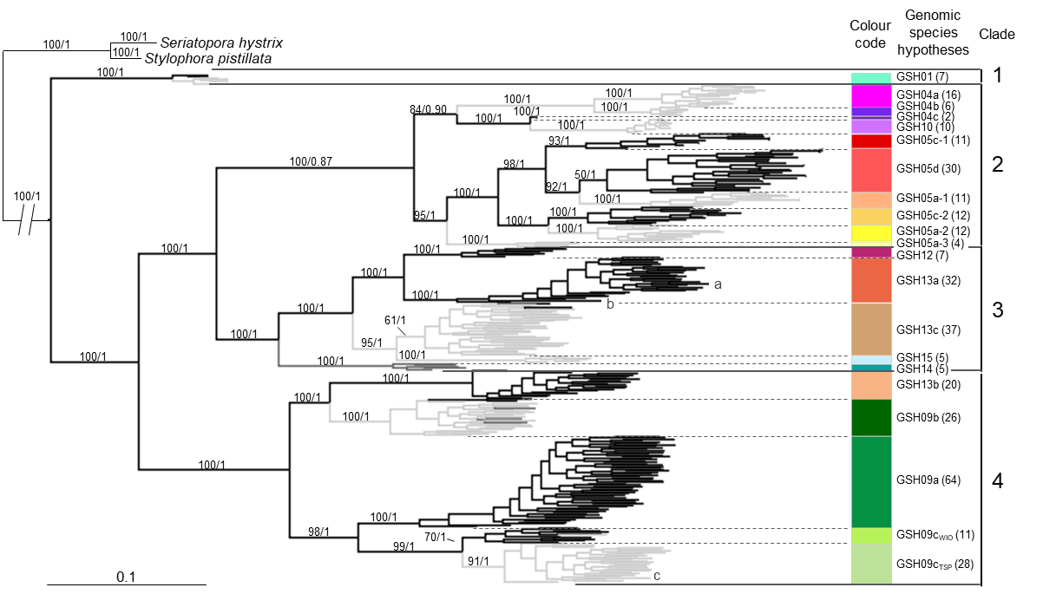

References
Buitrago-López C, Mariappan KG, Cardenas A, Gegner HM, Voolstra CR (2020) The genome of the cauliflower coral Pocillopora verrucosa. Genome Biol Evol. doi: 10.1093/gbe/evaa184
Cunning R, Bay RA, Gillette P, Baker AC, Traylor-Knowles N (2018) Comparative analysis of the Pocillopora damicornis genome highlights role of immune system in coral evolution. Sci Rep. doi: 10.1038/s41598-018-34459-8
Vidal-Dupiol J, Chaparro C, Pratlong M, Pontaroti P, Grunau C, Mitta G (2019) Sequencing, de novo assembly and annotation of the genome of the scleractinian coral, Pocillopora acuta. BioRxiv. doi: 10.1101/698688
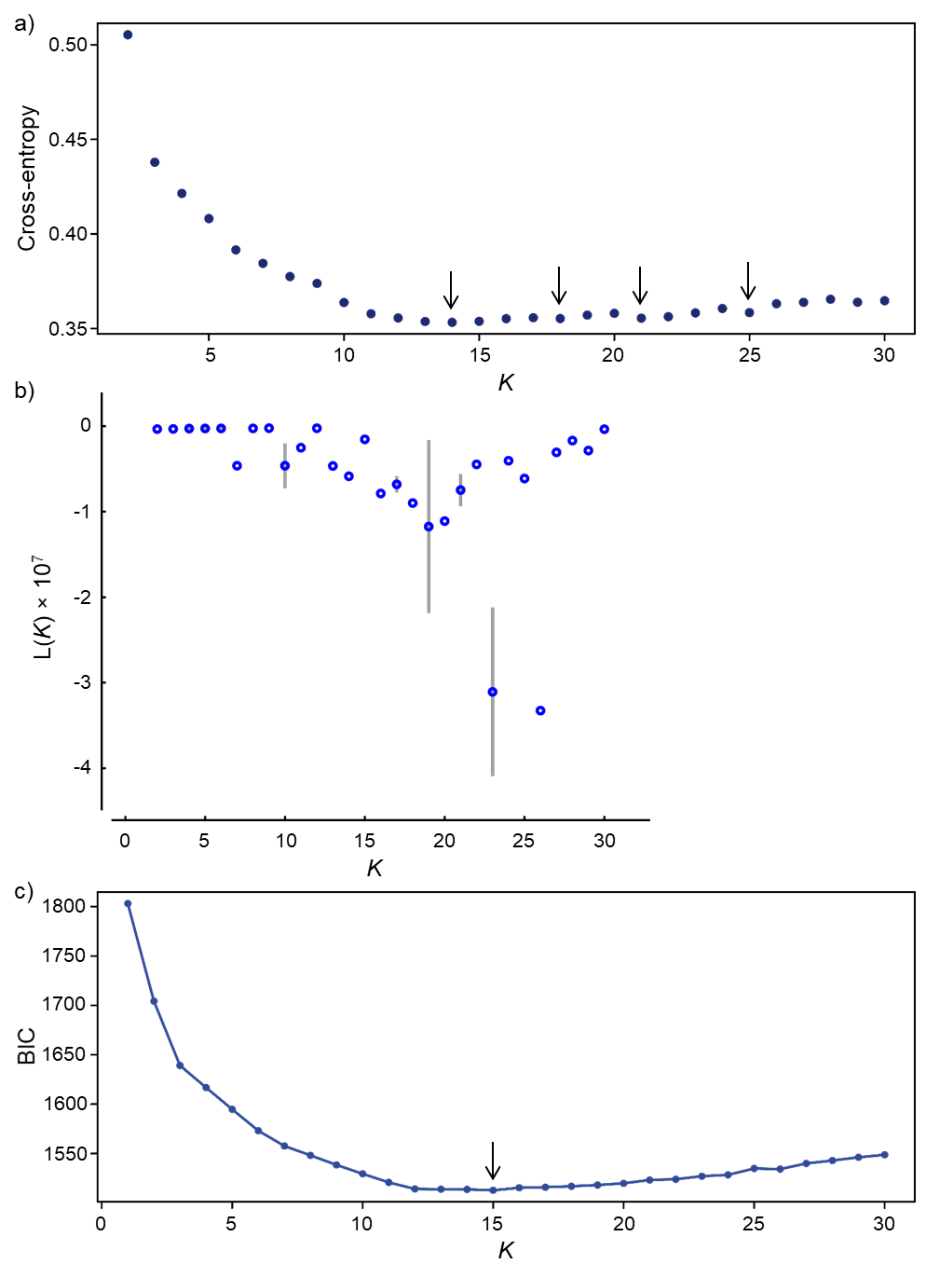
Fig. S3 Assignment tests with one SNP per locus (361 individuals × 1,559 SNPs). (a) cross-entropy (sNMF), (b) mean likelihood over the five iterations of the same K (Structure), (c) Bayesian information criterion (BIC; dAPC) and (d) plots of the three assignment methods (i.e., sNMF, Structure and dAPC) from K = 2 to K = 30, with individuals grouped by genomic species hypothesis (GSH; indicated above). Assignments for the three published genomes [a: P. verrucosa (Buitrago-López et al. 2020); b: P. acuta (Vidal-Dupiol et al. 2019); c: P. damicornis (Cunning et al. 2018)] are detailed on the right panel.

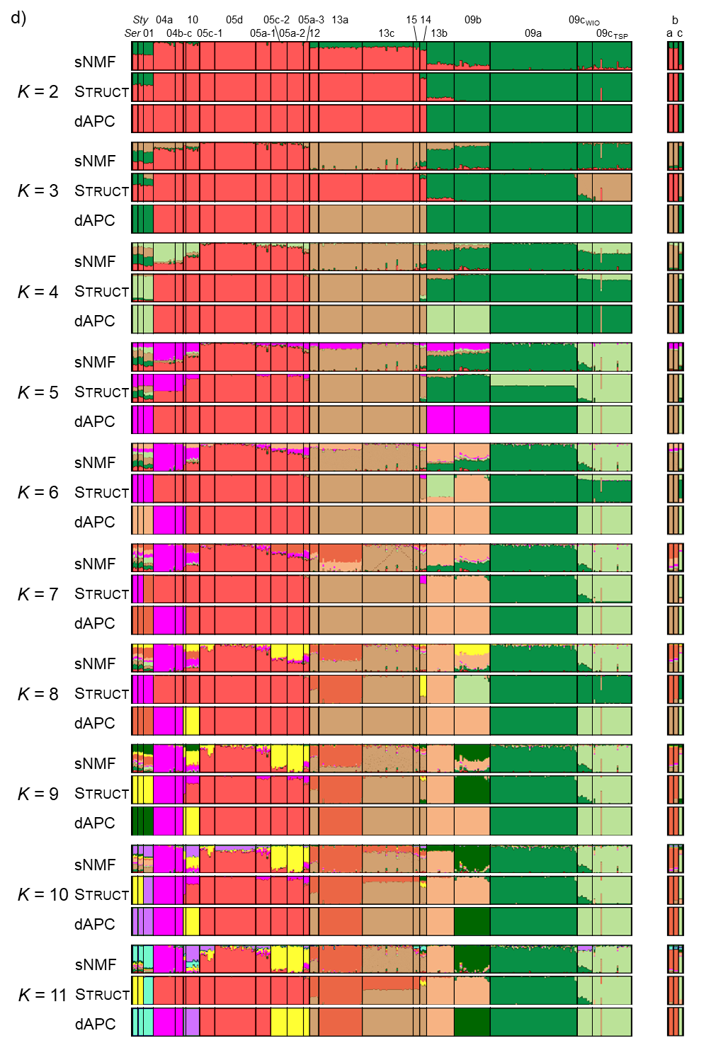
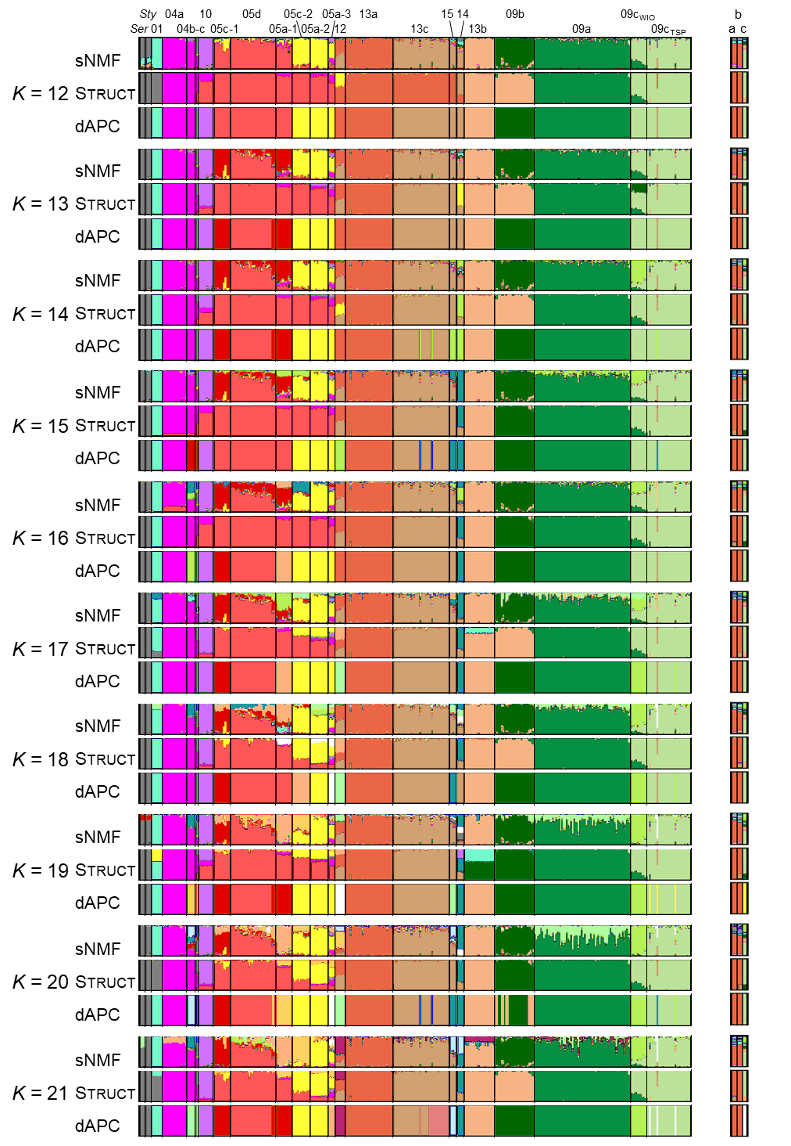
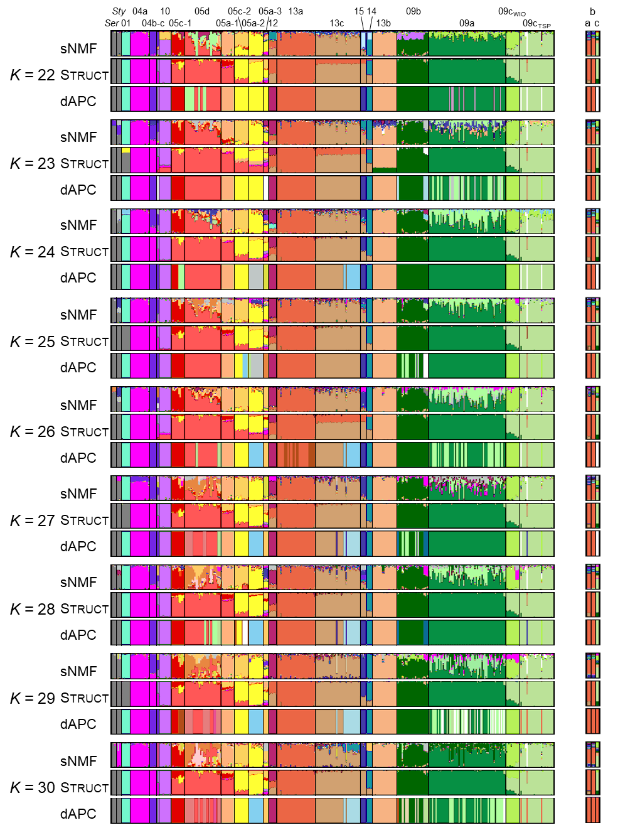
References
Buitrago-López C, Mariappan KG, Cardenas A, Gegner HM, Voolstra CR (2020) The genome of the cauliflower coral Pocillopora verrucosa. Genome Biol Evol. doi: 10.1093/gbe/evaa184
Cunning R, Bay RA, Gillette P, Baker AC, Traylor-Knowles N (2018) Comparative analysis of the Pocillopora damicornis genome highlights role of immune system in coral evolution. Sci Rep. doi: 10.1038/s41598-018-34459-8
Vidal-Dupiol J, Chaparro C, Pratlong M, Pontaroti P, Grunau C, Mitta G (2019) Sequencing, de novo assembly and annotation of the genome of the scleractinian coral, Pocillopora acuta. BioRxiv. doi: 10.1101/698688
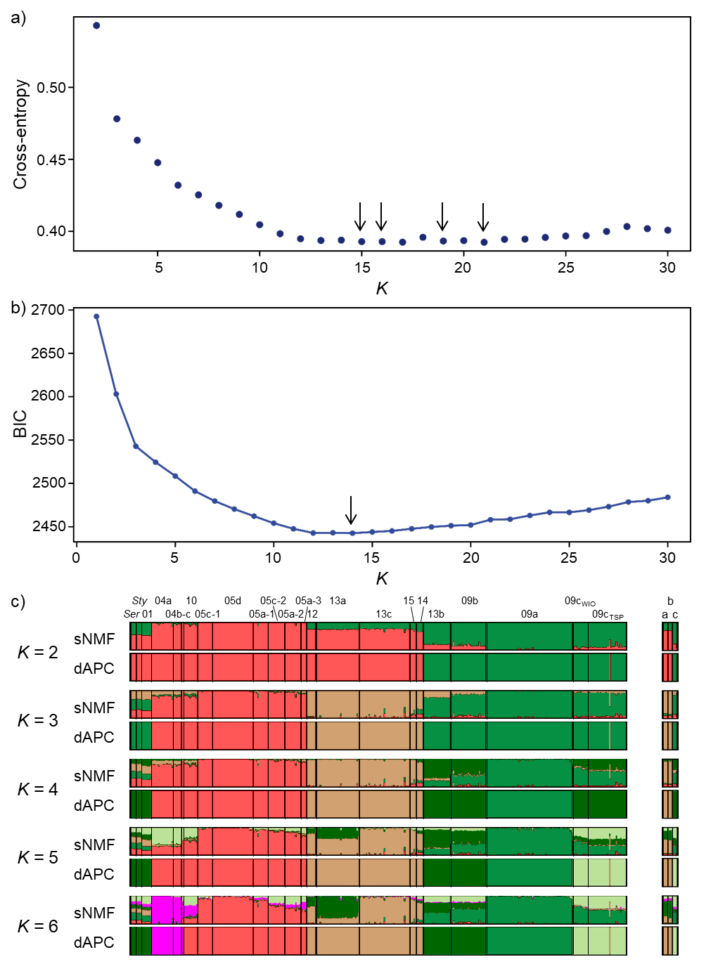
Fig. S4 Assignment tests with all SNPs (361 individuals × 17,465 SNPs). (a) cross-entropy (sNMF), (b) Bayesian information criterion (BIC; dAPC) and (c) plots of the two assignment methods (i.e., sNMF and dAPC) from K = 2 to K = 30, with individuals grouped by genomic species hypothesis (GSH; indicated above). Assignments for the three published genomes [a: P. verrucosa (Buitrago-López et al. 2020); b: P. acuta (Vidal-Dupiol et al. 2019); c: P. damicornis (Cunning et al. 2018)] are detailed on the right panel.

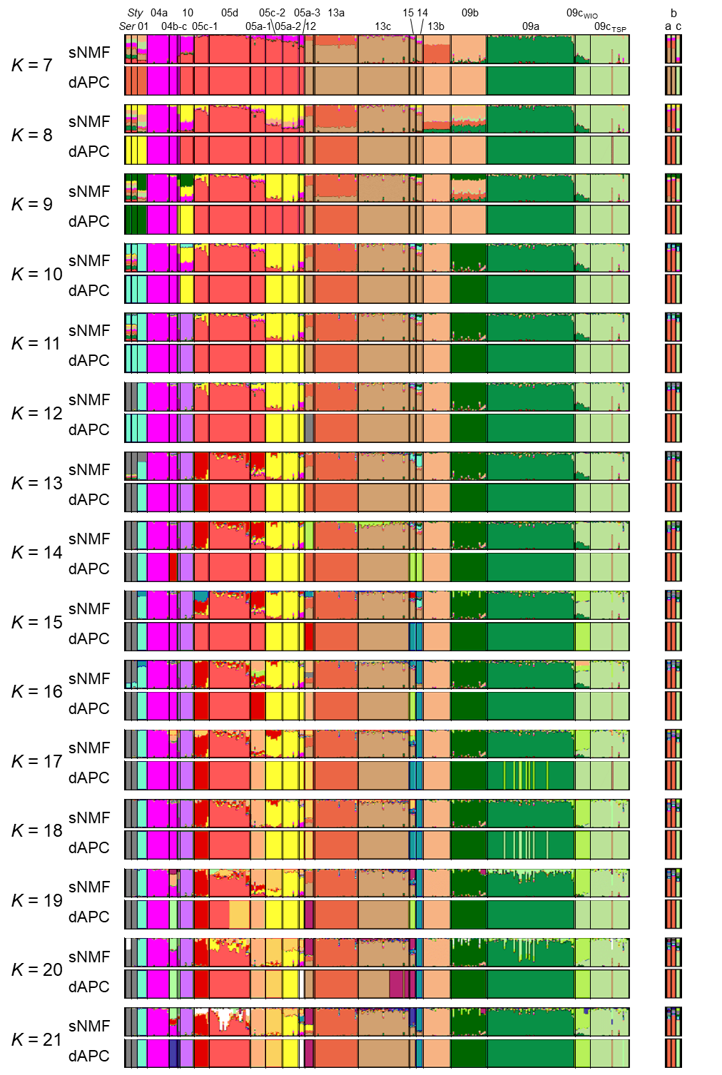
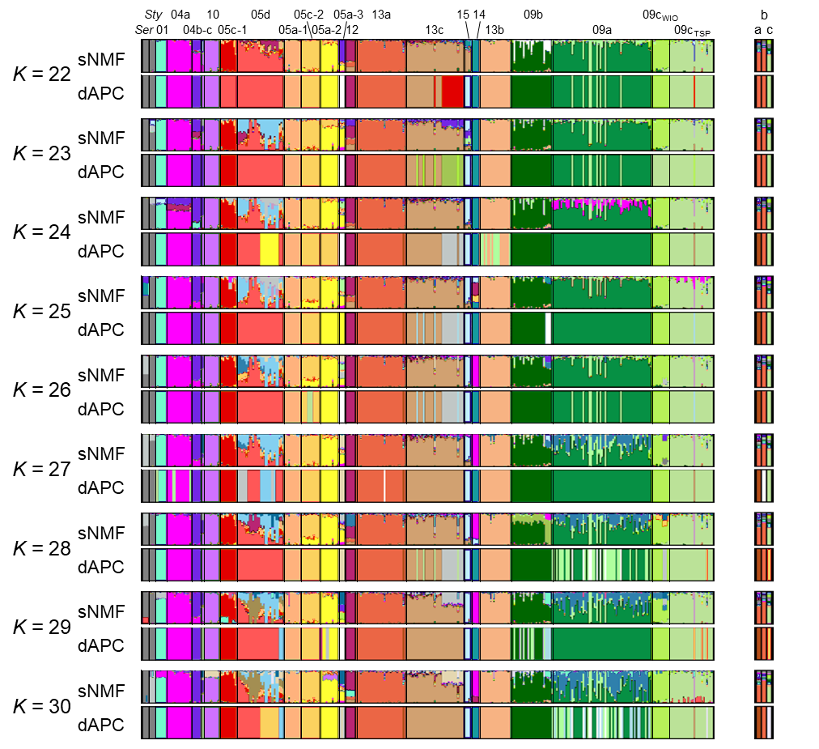

References
Buitrago-López C, Mariappan KG, Cardenas A, Gegner HM, Voolstra CR (2020) The genome of the cauliflower coral Pocillopora verrucosa. Genome Biol Evol. doi: 10.1093/gbe/evaa184
Cunning R, Bay RA, Gillette P, Baker AC, Traylor-Knowles N (2018) Comparative analysis of the Pocillopora damicornis genome highlights role of immune system in coral evolution. Sci Rep. doi: 10.1038/s41598-018-34459-8
Vidal-Dupiol J, Chaparro C, Pratlong M, Pontaroti P, Grunau C, Mitta G (2019) Sequencing, de novo assembly and annotation of the genome of the scleractinian coral, Pocillopora acuta. BioRxiv. doi: 10.1101/698688
Fig. S5 Networks based on Nei (1972) individual genetic distances for the datasets with (a) one SNP per locus (361 individuals × 1,559 SNPs) and (b) all SNPs (361 individuals × 17,465 SNPs), without outgroups: unrooted equal-angle split network (left panels) and minimum spanning tree (MST; right panels). Nodes and branches were coloured according Pocillopora genomic species hypotheses (GSHs). Published genomes are indicated by lowercase letters [a: P. verrucosa (Buitrago-López et al. 2020); b: P. acuta (Vidal-Dupiol et al. 2019); c: P. damicornis (Cunning et al. 2018)].
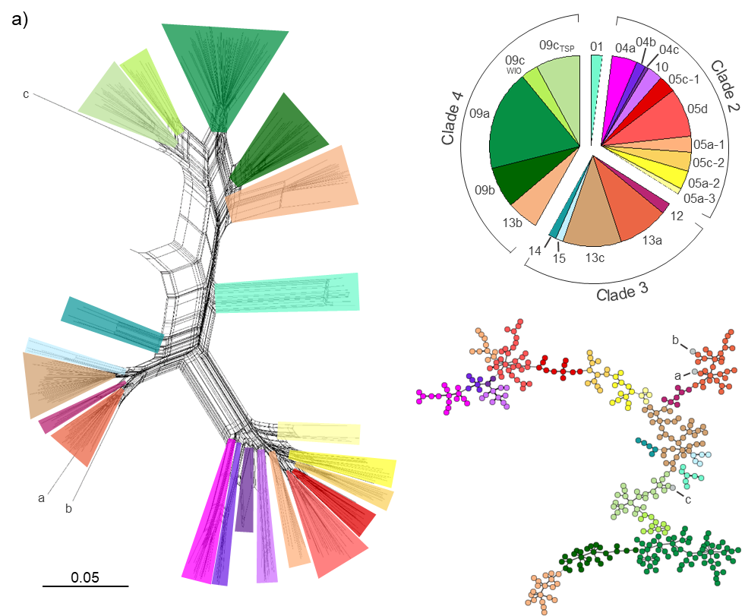

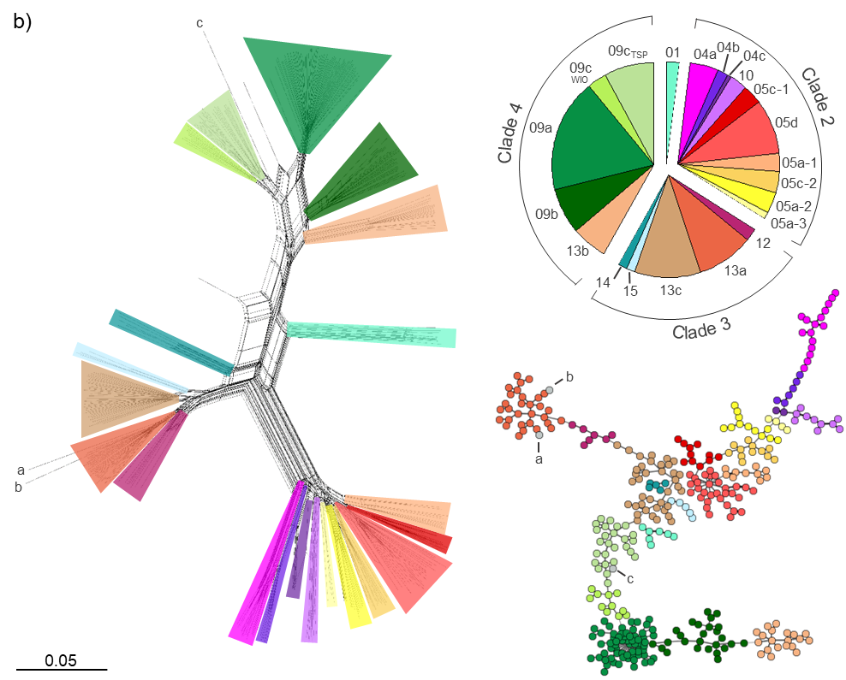

References
Buitrago-López C, Mariappan KG, Cardenas A, Gegner HM, Voolstra CR (2020) The genome of the cauliflower coral Pocillopora verrucosa. Genome Biol Evol. doi: 10.1093/gbe/evaa184
Cunning R, Bay RA, Gillette P, Baker AC, Traylor-Knowles N (2018) Comparative analysis of the Pocillopora damicornis genome highlights role of immune system in coral evolution. Sci Rep. doi: 10.1038/s41598-018-34459-8
Nei M (1972) Genetic distance between populations. Am Nat 106:283–292. doi: 10.1086/282771
Vidal-Dupiol J, Chaparro C, Pratlong M, Pontaroti P, Grunau C, Mitta G (2019) Sequencing, de novo assembly and annotation of the genome of the scleractinian coral, Pocillopora acuta. BioRxiv. doi: 10.1101/698688
Fig. S6 F_{ST} (Weir and Cockerham 1984) between Pocillopora genomic species hypotheses (GSHs) for the datasets with (a) one SNP per locus (361 individuals × 1,559 SNPs) and (b) all SNPs (361 individuals × 17,465 SNPs). The heat map represents the F_{ST} matrix (Table S7), with GSHs sorted according to the collapsed maximum-likelihood tree (ML-Tree; see also Fig. 1 & S2) in rows, and the F_{ST} clustering in columns, for comparison. Main clades are separated by lines. Ser: Seriatopora hystrix and Sty: Stylophora pistillata.
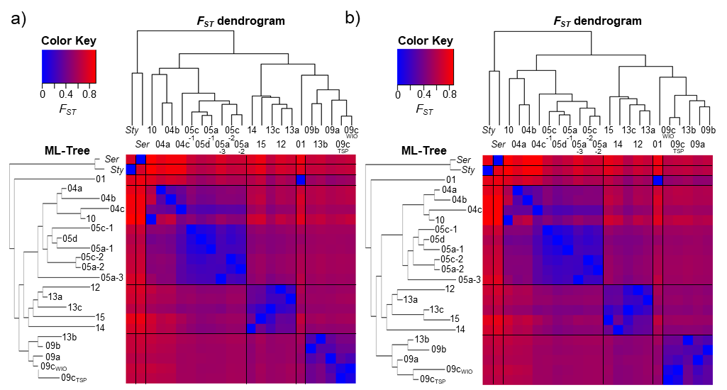

Reference
Weir BS, Cockerham CC (1984) Estimating F-statistics for the analysis of population structure. Evolution 38:1358–1370. doi: 10.1111/j.1558-5646.1984.tb05657.x
Fig. S7 Maximum likelihood (ML) phylogenetic tree reconstructed with the PocHistone haplotypes, keeping one representative per haplotype (occurrence in parentheses). Values at nodes indicate bootstrap support (over 100 iterations).
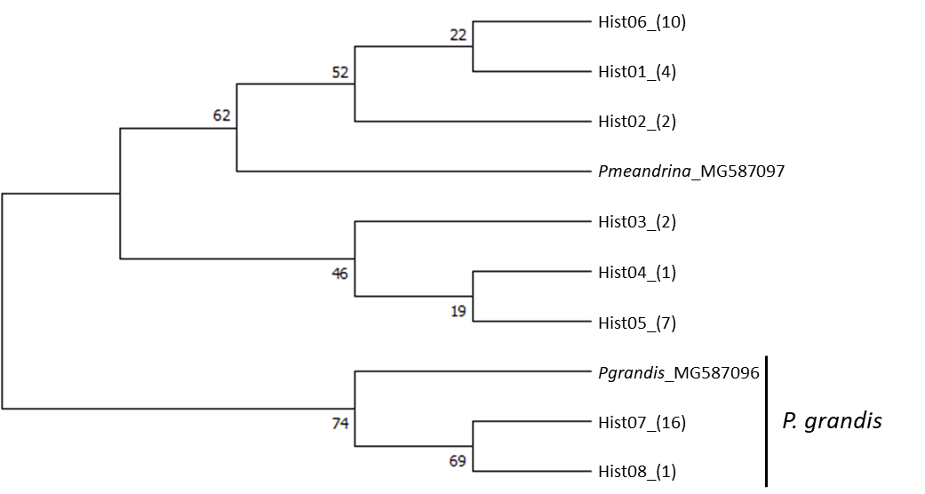
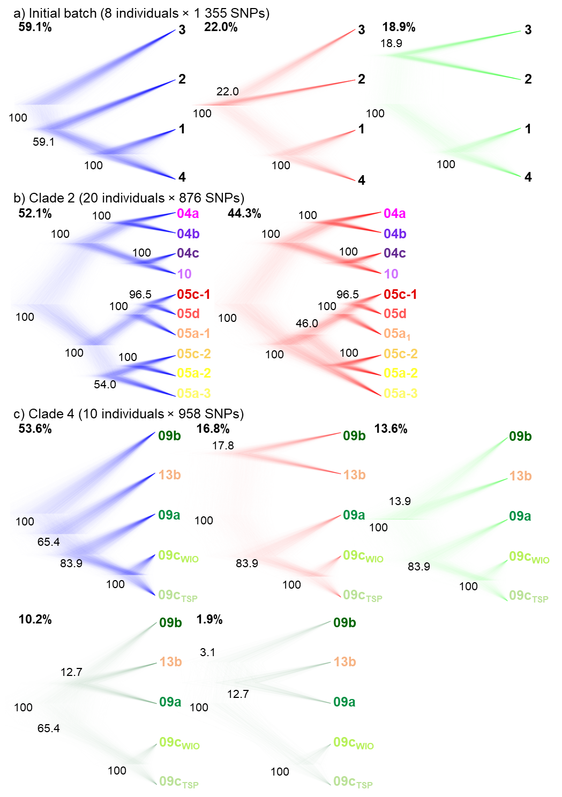
Fig. S8 Alternative species tree topologies identified in the 95% highest posterior density (HPD) set for each best-supported species model: (a) Initial batch, (b) Clade 2 and (c) Clade 4 (numbers of individuals and SNPs used for each batch of scenarios indicated above). Node support (Bayesian posterior probability) and proportion of represented trees (out of 10⁴) are shown.

